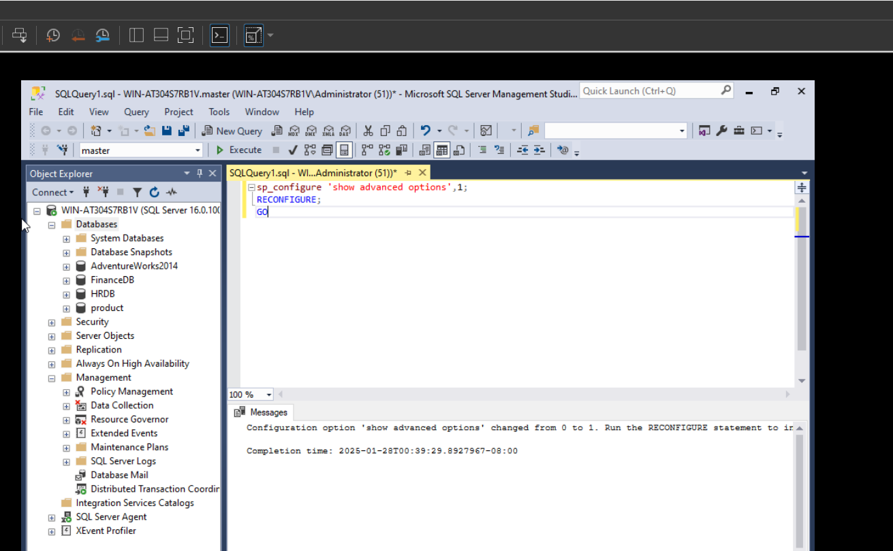
Firstly, I need to enable Database Mail XPs , I configured to show advanced options to see 69 options instead of 17 and then I configured Database Mail XPs from 0 to 1 and then again configured show options not to 69 because of security breach: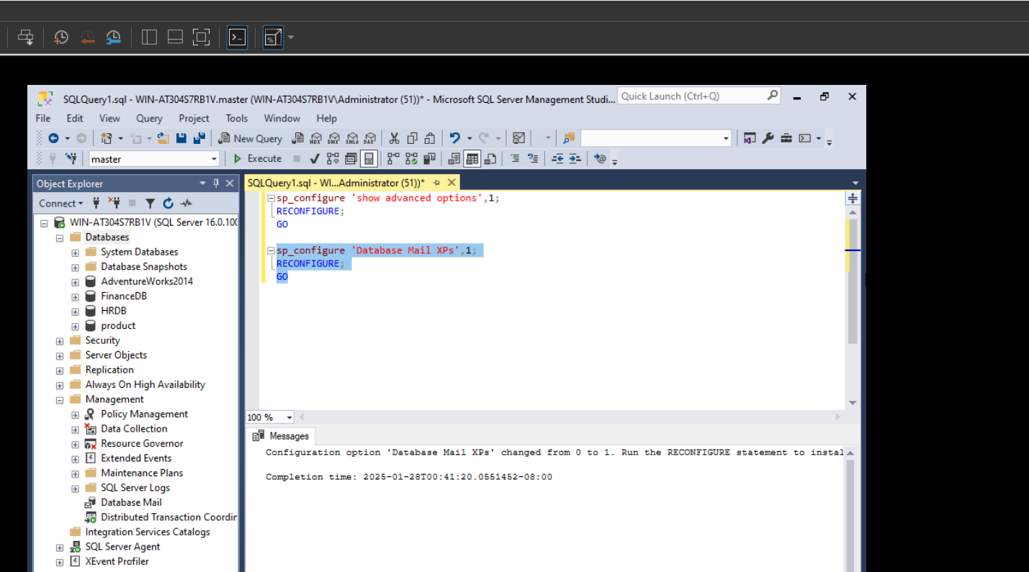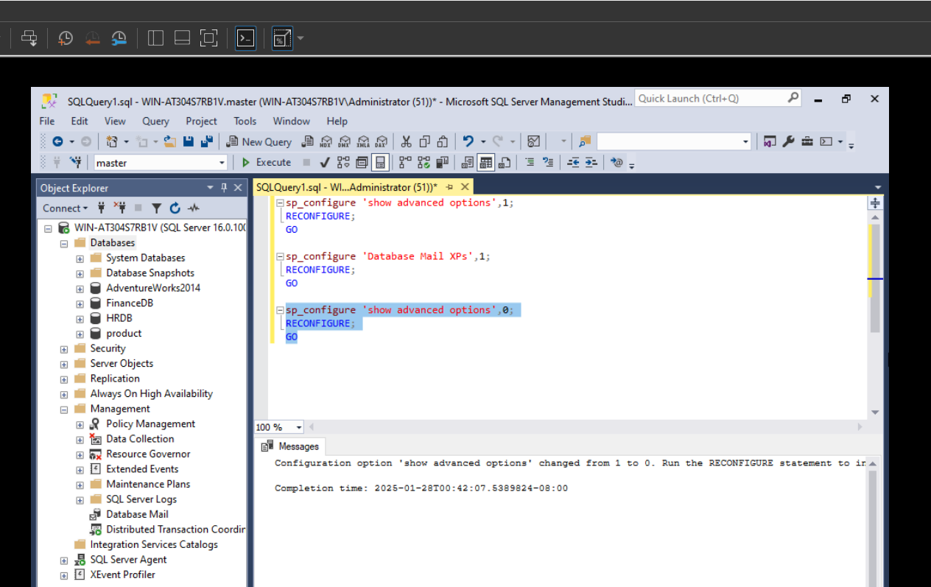
After these, I checked to see whether Service Broker is enabled or not and it shows 1 so it’s enabled.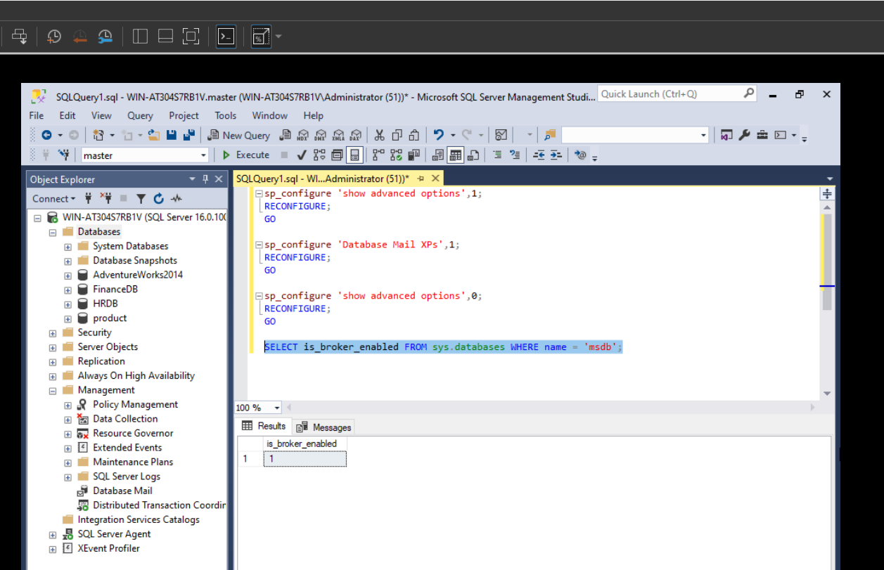
And then I added new profile and new account and associated them with each other to send emails: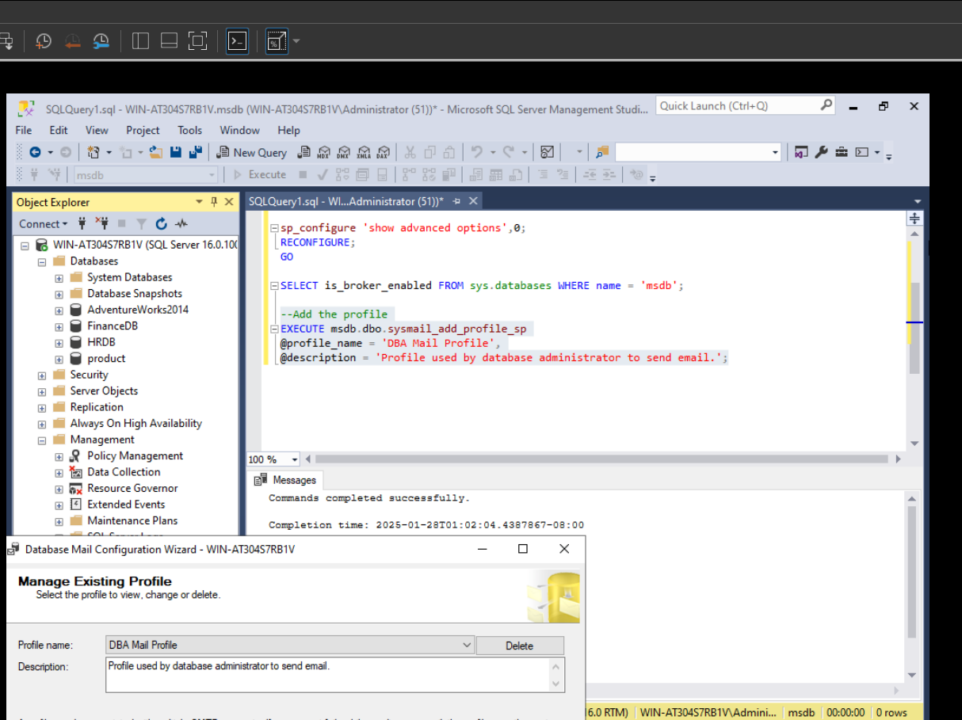
I researched about Gmail accounts apppasswords and port number and ssl enabled things and I understood that I need to create new custom app name and using its 16 character password and port number 587 and server name ‘smtp.gmail.com’, I can create my account and it worked: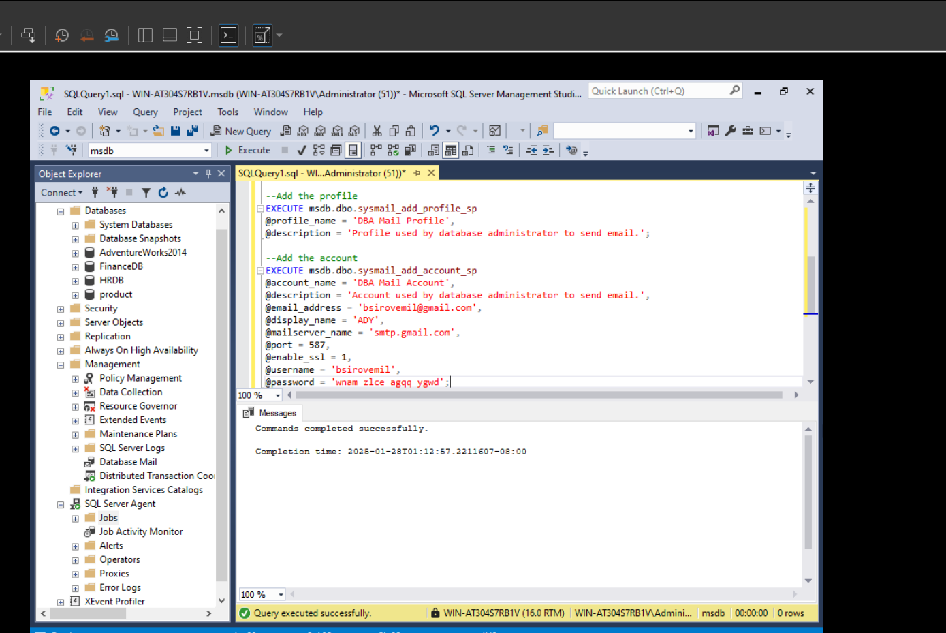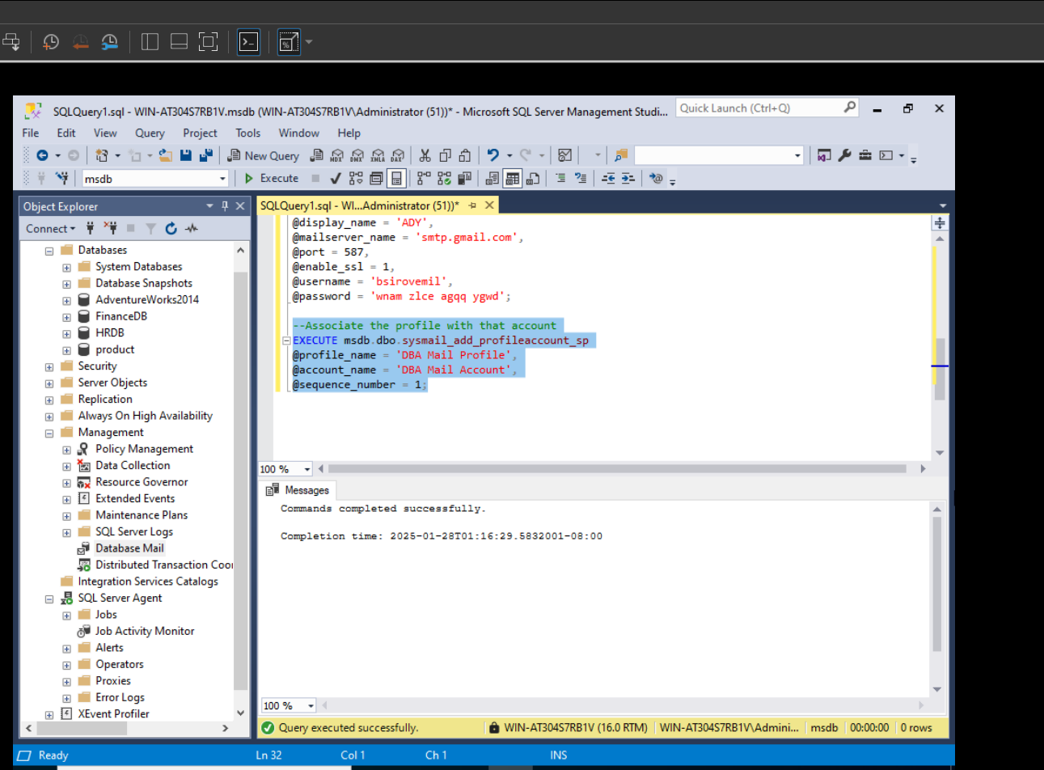
I tested it by using GUI and sent test email to check if it works or not and I saw the email has received after like 10 seconds: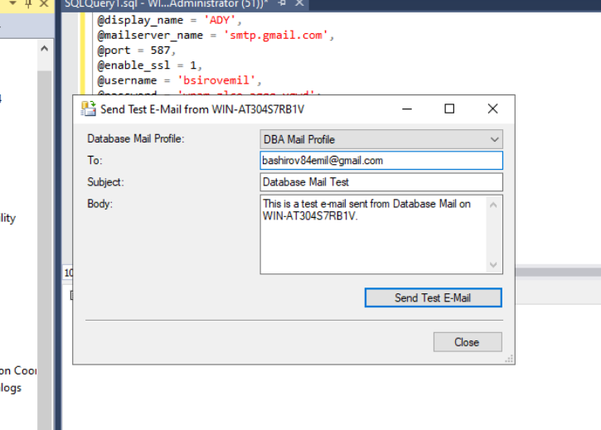
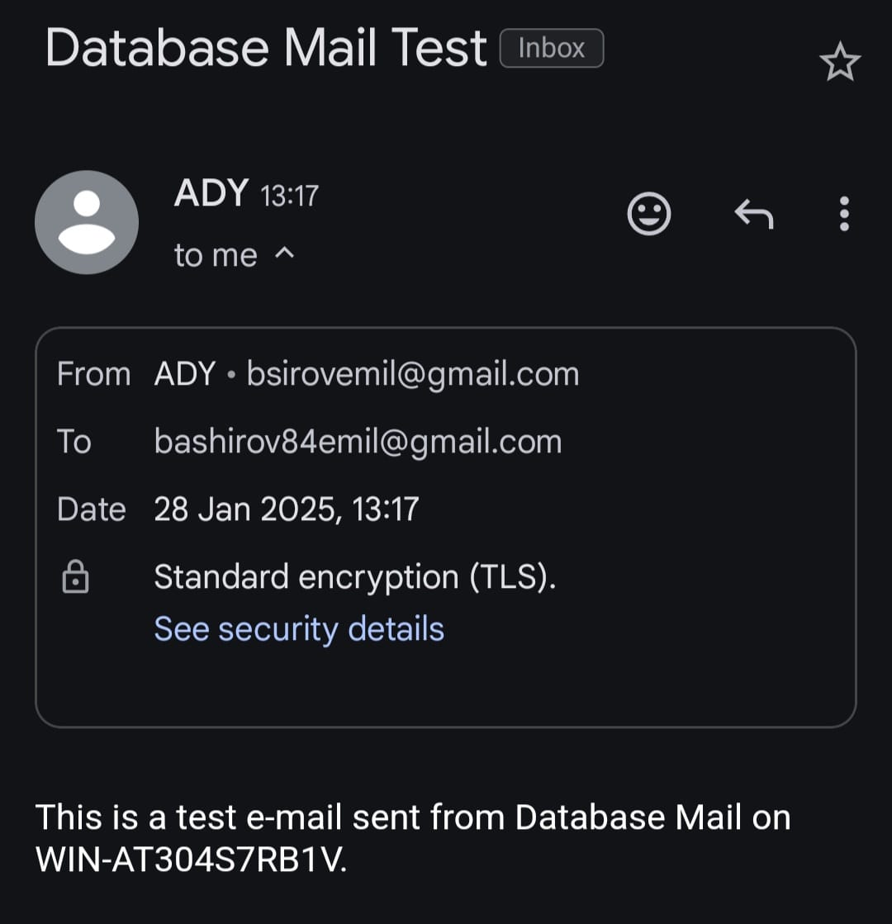
Then I used T-SQL script to send gmail to myself and other recipient and it also worked correctly: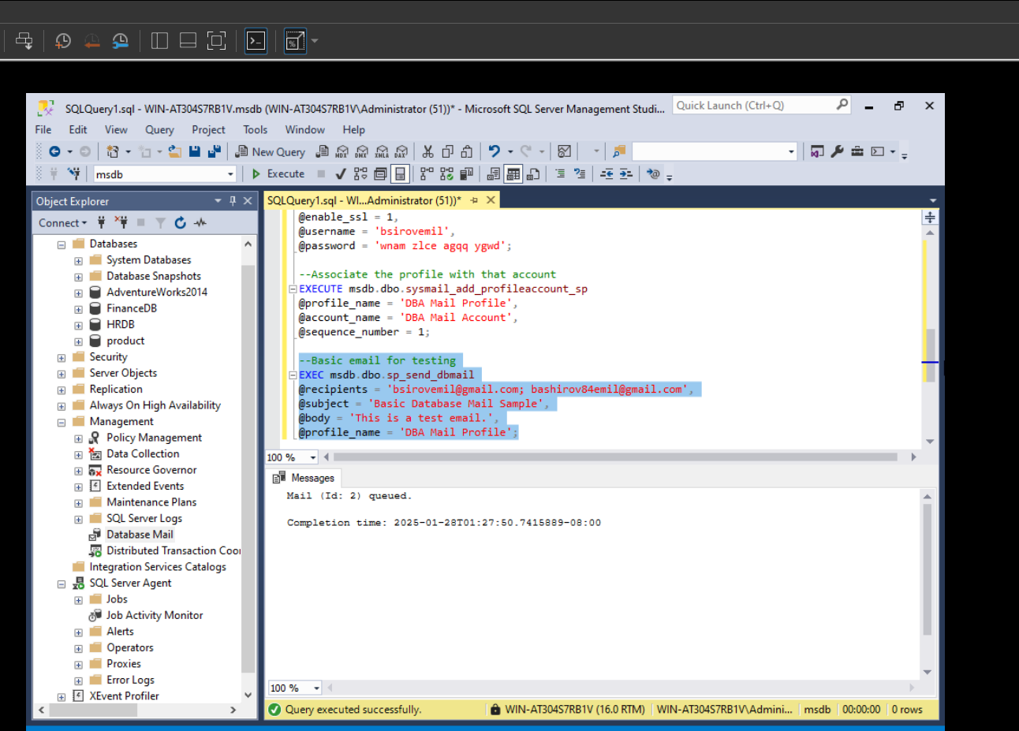
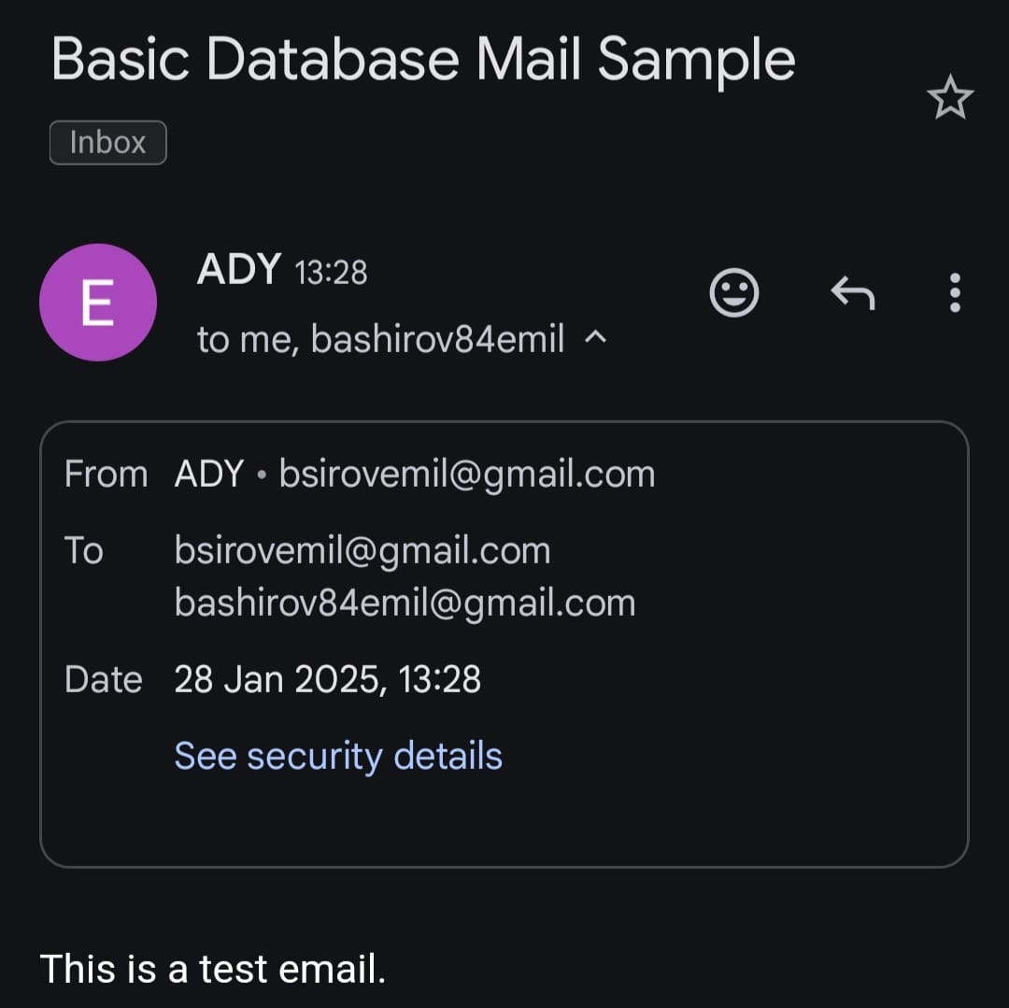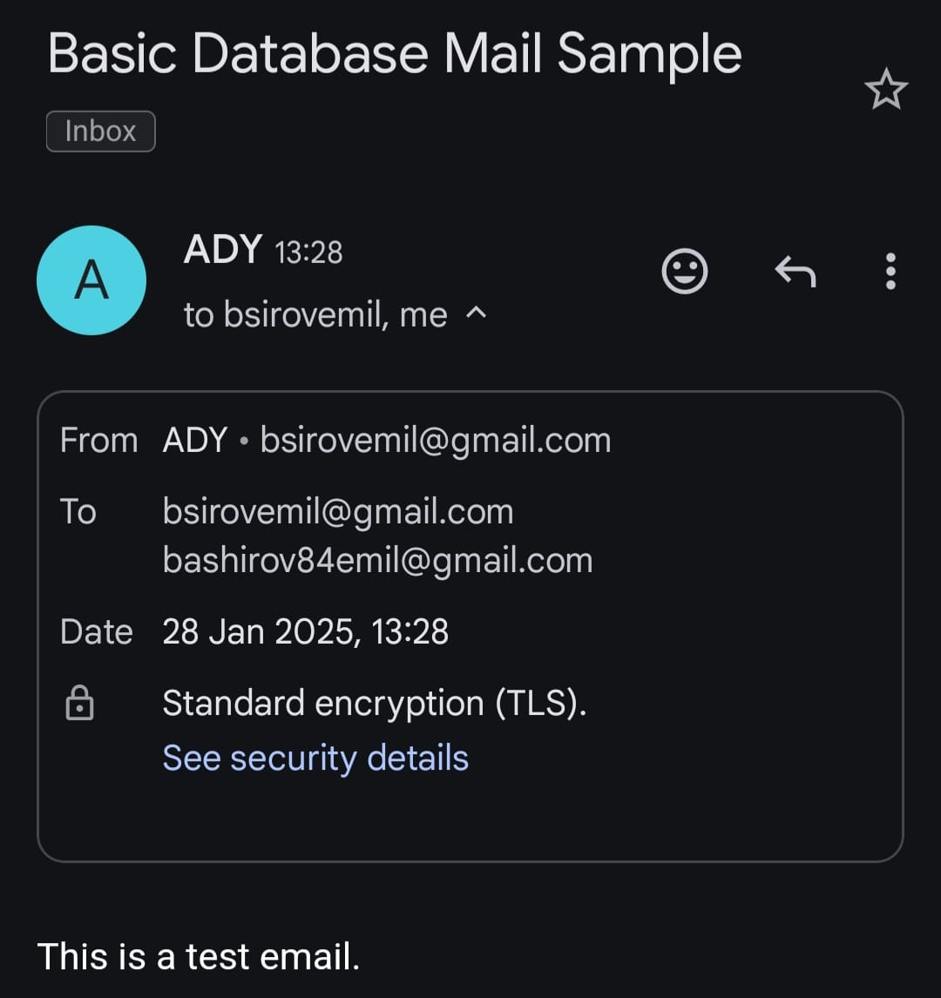
Then I used other useful queries to see more about sent and unsent emails: